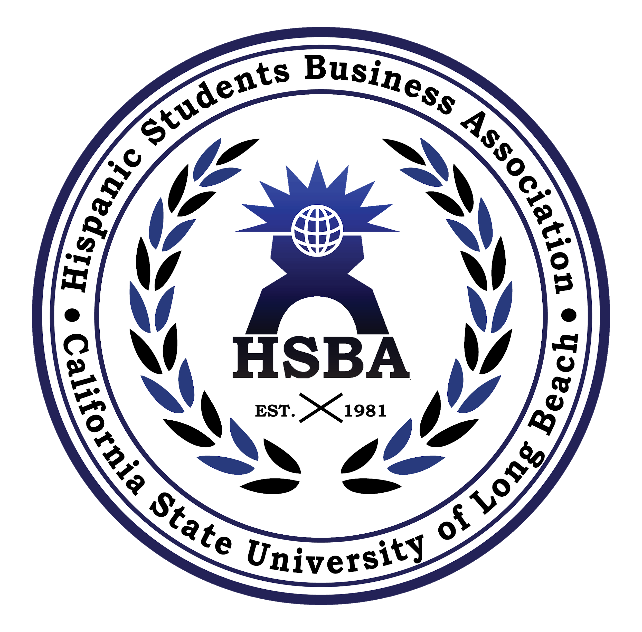
HSBA UNITY SCHOLARSHIP APPLICATION 2019

This year the Hispanic Students Business Association will be awarding scholarships to deserving HSBA members. To qualify you must:

- ● Be a paid active member or director during the Fall 2018/ Spring 2019 semester. ● Be currently enrolled as a student at CSULB and eligible to return for Fall 2019 as a student and paid member.
- ● Have attended at least 12 events if a paid member since Fall 2018/ or at least 6 events since Spring 2019.
- ● Strong preference would be given to those with most active participation in ABSOC, ULSA, and LSU events.
- ● Have a minimum 2.5 GPA

- Essay question:
- In a one page typed essay, not to exceed 600 words (double spaced, 10 pt fonts), describe how your active participation in organizations such as the Associated Business Student Organization Council, United Latino Students Association, and Latino Student Union have contributed to the focus of uniting students of all nationalities and majors. Please feel free to include specific events and demonstrations of group unity.

- Name:__________________________ContactNo.:___________________________
- Email:_______________________________ Class Level:______________________
- Major:_______________________________ Expected Graduation:______________
- Events attended:_______________________________________________________ _____________________________________________________________________ _____________________________________________________________________ Signature:______________________________ Date:_____________________

- Once you have completed both the application and essay please submit it to HSBA’s Treasurer no later than 11:59 pm on Wednesday, April 24, 2019 via email. Your essay will be read and selected by the HSBA Executive Board. Scholarship recipients will be awarded at the HSBA banquet on May 3rd, 2019.
- If you have any questions, please contact Janpier Adamzadeh (310) 918-5225 treasurer.csulb.hsba@gmail.com.

